 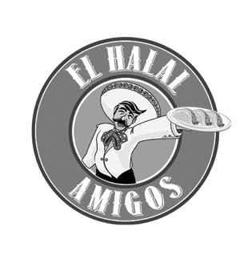

2023

Dear Community Member,

Willow Street Pizza and El Halal Amigos are proud to have remained a supportive, active member of the community. As part of our ongoing effort to be of service to our neighbors, we are pleased to continue the “Giving Back” program. This is a simple, fun way to raise funds for local non-profit organizations.

We are now in the process of scheduling Giving Back Events. Book your fundraising event early to ensure that you get the date you want. These events are available on **Mondays and Wednesdays** (excluding holidays).

On the day of your scheduled event, we will donate a percentage of all food and beverage purchases generated by your group. Willow Street will donate 20% and El Halal Amigos will donate 15% (before sales tax & tip). Please note that we will not accept any other coupons, scrip or discounts during this event. Take-out orders are welcome, but any delivery orders (ie: Door Dash) are NOT eligible for fundraisers.

Getting started is simple. Fill out the attached form and email it to us. Or send the requested information to [michelle@willowstreet.com](mailto:michelle@willowstreet.com). Once we confirm a date for your fundraiser, we will create a flyer specific to your organization that you may email or distribute to publicize the event.

We have three convenient locations to choose from for your fundraiser.

**Willow Street Wood Fired Pizza Willow Street Wood Fired Pizza El Halal Amigos**

**20 S. Santa Cruz Ave, Ste 218 1072 Willow Street 1100 Lincoln Ave #160**

**\Los Gatos, CA 95030 San Jose, CA 95125 San Jose, CA 95125**

Sincerely,

Michelle DeSpain

michelle@willowstreet.com

Giving Back Coordinator

**Phone 408.399.5501 willowstreet.com elhalalamigos.com**

**Willow Street Pizza & El Halal Amigos Give Back Information**

* Willow Street Pizza & El Halal Amigos Giving back program is available Mondays and Wednesdays throughout the year (excluding holidays). The fundraiser will run all day during lunch and dinner.
* Willow Street will donate 20% and El Halal Amigos will donate 15% of all food and beverage sales for dine in and take out (before sales tax and tip) that your organization generates. Anyone dining in for the fundraiser will need to present a flyer when dining so that we may keep track of sales.
* No other coupons or discounts are to be used during the giving back fundraiser, as this will defeat the purpose of earning the most money for your organization.
* If possible, please try to have several dates that you would like to book your fundraiser with us, as we book up quickly and the dates might be previously booked. This will help expedite the process.
* We as that you try to book your even 3-4 weeks out to give your organization enough time to publicize your event.
* Please do not solicit our customers with flyers in or around the restaurant.
* You will need to use the flyer we provide for you. If you want to use your own flyer, it must be pre-approved by our business office.
* Please do not start publicizing your even until you hear a confirmation from us.
* After the event, please allow two to three weeks for your check.
* NOTE: Please deposit your check promptly, as they will be voided after 60 days.

**For any other information on the fundraising program, please email** [**Michelle@willowstreet.com**](mailto:Michelle@willowstreet.com)**.**